# CS 255 System Design Document Template

Justin Farquhar

## UML Diagrams

### UML Use Case Diagram

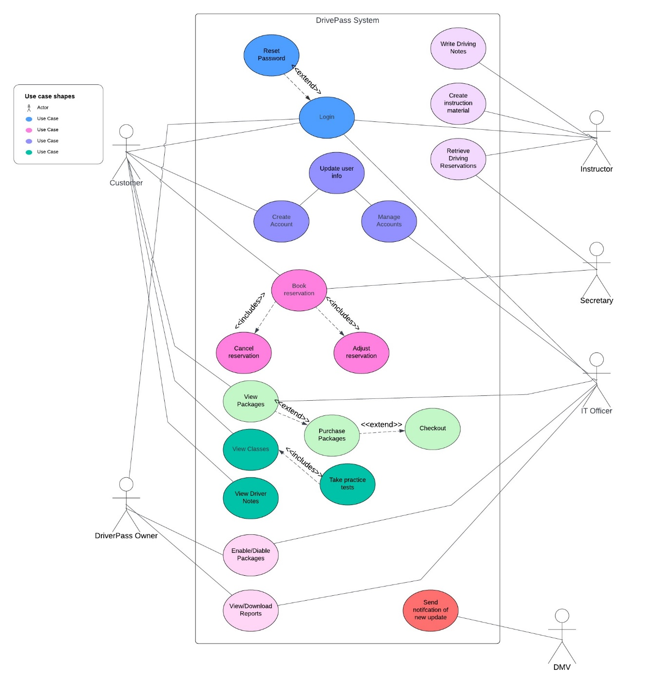

### UML Sequence Diagram

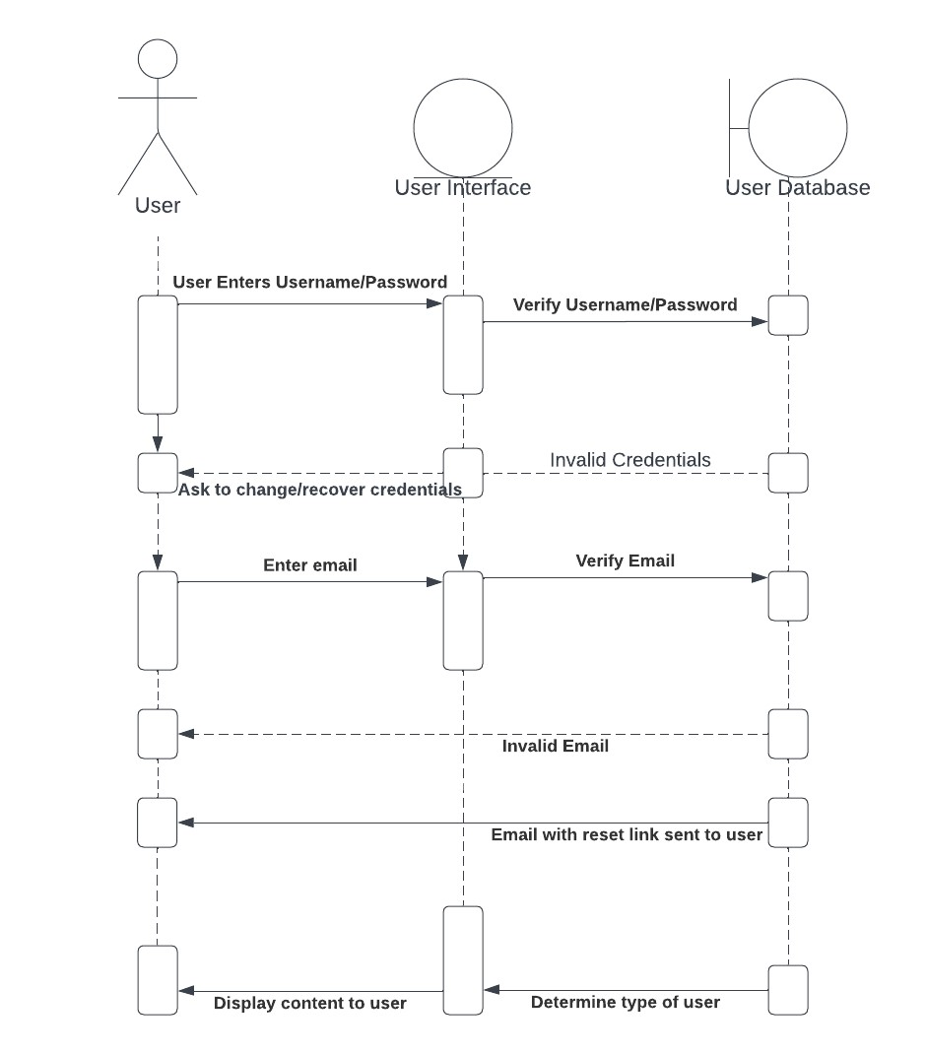

### UML Class Diagram

Included a few relevant methods to prevent excess whitespace and where context would be helpful.

## Technical Requirements

**Performance Requirements:**

* Web-based environment in the cloud.
* Load times should be responsive, within a few seconds.
* There should be an indication if load times are longer than 4 seconds.
* The system should be updated as needed or at a minimum every month.

**Platform Constraints**

* The system should universally run on computer and mobile browsers.
  + Support for Windows and Apple.
    - Google Chrome.
    - Internet Explorer/Edge.
    - Safari.
    - Firefox.
* Backend will include a database to store information.
* Backend will include a web server to handle responses.
* All Backend functions will be maintained outside of DriverPass.

**Software/Hardware**

* Software will continue to be done on Java.
  + Could need to adjust depending on outsourced database software.
* It is assumed that all students/instructors/employees will have adequate hardware and internet connection.
* It is assumed that all students/instructors/employees will have a basic knowledge of operating and navigating an online environment.

**Infrastructure**

* The system will require a cloud-based web server.
* The system will require appropriate references to the databases.